CURRICULUM VITAE

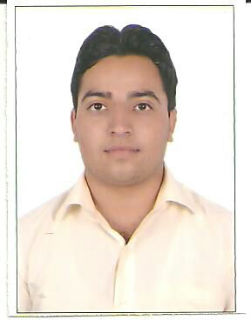
MOHIT SHARMA
Email: mohitsharma.18292@gmail.com
D.O.B: March 2, 1992
Gender: Male
Nationality: Indian
Language proficiency: English, Hindi, Punjabi

CAREER OBJECTIVES

To secure a career in a reputed organization, where i can utilize my knowledge and skills to contribute towards fulfilling the company’s growth objectives, develop my career and excel in the related field.

To secure a career in a reputed organization, where i can utilize my knowledge a
ACADEMIC CREDENTIALS

Master in Business Administration (MBA) (2014)  Lovely Professional University (L.P.U), Punjab. | 7.39(CGPA)
Bachelor of Commerce (2012)  KLSD College, Ludhiana, Punjab.  (Affiliated to Punjab University) | 67.72%
Senior Secondary Certificate Examination (2009)  (Grade XII)  Arya Sen.Sec. School, Ludhiana, Punjab (affiliated to P.S.E.B) | 66.22%
Matriculation (2007)  (Grade X)  B.B. public School, Ludhiana, Punjab (affiliated to P.S.E.B) | 68.47%

TECHNICAL SKILLS

- Proficiency in MS-Office
- Proficiency in SPSS
SUMMER INTERNSHIP/ PROJECTS UNDERTAKEN

Organization: B.D.R Products (India) Pvt. Ltd.
Period: 1st June to 15th July 2013.
Project title: Comparison of B.D.R Products (India) Pvt Ltd. with its competitors & growth potential
Objectives: To checkout satisfaction level of consumers.
To find out growth potential of company.

WORK EXPERIENCE: 4 months (as a Showroom Manager in airtel)
STRENGTHS

- Self confidence
- Adaptable
WEAKNESSES

- Work alcoholic
- Stubborn
WORKSHOPS

- Workshop on Excel Modelling.
- Workshop on Innovation and Creativity.
- Workshop on Business Simulation.
- Workshop on Adobe Photoshop.
CO- CURRICULAR ACTIVITIES

- Attempted AMCAT examination
- Attempted WEST
- Attempted NCFM module
HOBBIES

- Watching & playing cricket
ADDRESS & CONTACT
Residential Address
F/2 3132, New Gurnam Nagar, Jassian Road, Ludhiana-141008, Punjab.
Contact
Mobile: +919501404074
Place: LUDHIANA.

